EQUINE HAVEN Ltd
Jumper Series Horse Shows

Ribbons to 6th place; Prize Money to 5th place.
Champion and Reserve Champion in Each Division
Points Earned for Equine Haven Year End Awards
Entries Limited to 50 Riders/Day
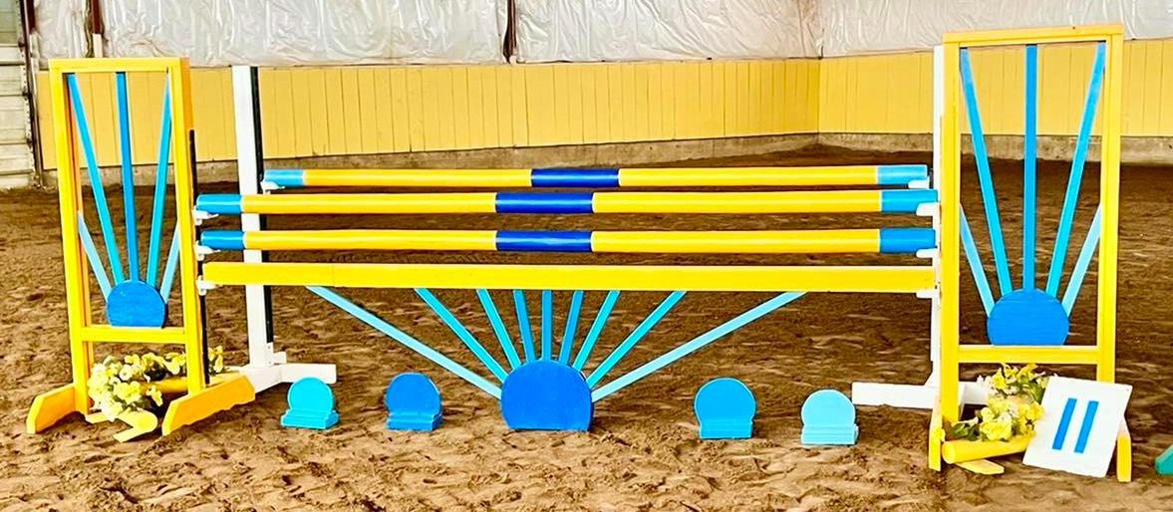
Course Designer: Crystal Turko
Judge: Sadie Turko
General Inquiries and Entry Forms: info@equinehaven.ca
E-transfers for entry fees can be sent to sadie.turko@equinehaven.ca
Spring Show Dates
March 1-3rd
April 12-14th
May 24-26th

Ribbons to 6th.

Champion and Reserve awarded for each division at every show and Year End awards for each division.

Prize Money: $15 from each Add Back entry will be divided as follows: 1st – 30%, 2nd – 25%, 3rd – 20%, 4th – 15%, 5th – 10%.

$35 Office Fee.

$15 Paramedic Fee.

$25 Scored Handy Jumper. (Bonus points awarded for efficient turns.
Points will be deducted for things like unsteady lines, rails down, or stops.)

$25 Equitation Challenge (A jumping and gymnastic course that will include up 3 – 4 level appropriate challenges mixed in, such as lengthen trot across a diagonal, or halt and back up five steps.)

$35 Add Back Table C Speed. (10 seconds will be added if the judge deems your speed to be unsafe. 4 seconds will be added for every rail knocked down.) $10 Add Back

$40 Add Back Table A Jump Off Stake. (Jump Off is not immediate and everyone can do it if they want but will place according to how they actually did in the first round with ties for 1st broken by the jump off round.)
$15 Add Back.

Save $10 by entering an entire division. (Already deducted in the division fee!)

If 3 or less people are in a division, consecutive divisions on the same day may be combined.

No one gets Eliminated as long as you keep trying (get back on if necessary once cleared by the paramedic) and finish your course!

Class List

Saturday

Division 1: Beginner Jumper (Trotting only) (Shorter, simpler courses) $65/division
1. Scored Handy Jumper over poles $25
2. Scored Handy Jumper over 6” X-Rails $25
3. Equitation Challenge over 6” X-Rails $25

Division 3: 15” X-Rail Jumper $80/division
7. Equitation Challenge $25
8. Scored Handy Jumper $25
9. Table A 2.2 Jump Off Add Back Stake $40

Division 5: .55m Jumper (No oxers), $80/division
13. Equitation Challenge $25
14. Scored Handy Jumper $25
15. Table A 2.2 Jump Off Add Back Stake $40

Division 7: .7m Jumpers, $90/division
19. Equitation Challenge $25
20. Table C Speed Stake $35
21. Table A 2.2 Jump Off Add Back Stake $40

Division 9: .85 Jumpers, $90/division
25. Equitation Challenge $25
26. Table C Speed Stake $35
27. Table A 2.2 Jump Off Add Back Stake $40

Division 11: 1.0m Jumpers, $90/division
31. Equitation Challenge $25
32. Table C Speed Stake $35
33. Table A 2.2 Jump Off Add Back Stake $40

Sunday

Division 2: Novice Jumper (trotting only) (Shorter, simpler courses) $65/division
4. Scored Handy Jumper over 9” X-Rails $25
5. Scored Handy Jumper over 12” X-Rails $25
6. Equitation Challenge over 12” X-Rails $25

Division 4: .45m Jumper (No oxers) $80/division
10. Equitation Challenge $25
11. Scored Handy Jumper $25
12. Table A 2.2 Jump Off Add Back Stake $40

Division 6: .6m Jumpers, $90/division
16. Equitation Challenge $25
17. Table C Speed Stake $35
18. Table A 2.2 Jump Off Add Back Stake $40

Division 8: .75m Jumpers, $90/division
22. Equitation Challenge $25
23. Table C Speed Stake $35
24. Table A 2.2 Jump Off Add Back Stake $40

Division 10: .9m Jumpers, $90/division
28. Equitation Challenge $25
29. Table C Speed Stake $35
30. Table A 2.2 Jump Off Add Back Stake $40

Division 12: 1.05/1.10m Jumpers, $90/division
34. Equitation Challenge $25
35. Table C Speed Stake $35
36. Table A 2.2 Jump Off Add Back Stake $40

Show Details
ADMINISTRATION: Equine Haven Ltd reserves the right to cancel or combine any given classes that do not fill to their satisfaction. All exhibitors in cancelled classes will be notified by either email or telephone (if number is provided on entry form) and any entry fees refunded. No advanced notification will be given for combined classes.
ADMINISTRATION: Equine Haven Ltd Summer Series Horse Shows are open to all riders; however, we reserved the right to refuse any entry, to make changes to arena classes run in, judges, or class order to best facilitate the running of the show. We also reserve the right to start each division up to 30 minutes earlier than the posted schedule if number of entries permit.
SAFETY: The judge reserves the right to eliminate any horse/rider combination that exhibits excessive speed, abuse to the horse, unsafe or unsportsmanlike behaviour, or lack of control, with no refund of fees.
ENTRY FORMS: Please fill out one entry form per horse/rider combination.
CANCELLATION POLICY: Cancellation before closing date of entries will receive a full refund. Cancellation after closing date but before the start of the horse show will receive a refund less the office fee. Cancellation after the start of the horse show, with proof of Vet Certificate, class fees for remaining classes will be refunded.
ADD/SCRATCHES: There will be no charge for adds/scratches the day before classes for horses already entered. Same day adds/scratches are acceptable but at a $10 charge, in addition to the class fee. Classes scratched the day before will be refunded; however, same day scratches are non-refundable.
LATE FEES: Entries received after the closing date for the show will pay a post entry fee of $20. Horses showing in a class without being entered will pay DOUBLE the class fee.
OPEN SCHOOLING/WARM-UP: Open schooling will be held on Fridays, and can be booked from 9am to 9pm (last schooling available to start at 9pm). Coaches may book schooling times for their students. A maximum of 6 riders allowed in the ring at any one time. Time allotment for schooling is based on number of riders per block. Cost is $25/rider. Warm ups will be held in the indoor arena prior to the commencement of each group of riders.
ACCOMODATIONS: Day stalls are available for a fee of $35/day, overnight stalls are $100 for the weekend. Bedding is included. Stalls are limited and priority will be assigned in the order entry forms are received.
HAUL INS: Trailering in is welcome for no additional fee; however, all horses and riders must be entered in the show and be assigned a number. Space for RVs will be made available on request. There will be no service hookups.
REFUSALS: Riders with two refusals will not be buzzed out of the ring. The top pole of the fence refused twice will be dropped to the ground and the rider will be allowed to continue to the conclusion of the course. Riders with 2 or more refusals will be placed last, but not eliminated.
PROTECTIVE HEADGEAR: All competitors must wear proper fitting and approve headgear, with safety harness correctly secured, at all times while mounted on the event grounds. Helmets must meet ASTM standards and display the SEI seal. The British standard BSI is also acceptable. Any rider found violating this rule will be prohibited from further riding on event grounds until a helmet is properly in place.
DOGS: No dogs are permitted on the event grounds.
ADD BACK STAKES: $15 from each entry will be added back as prize money. Distribution of prize money will be done according to the following: 1st – 30%; 2nd - $25%; 3rd – 20%; 4th – 15%, and 5th – 10%. Prize money will only be paid upon sign out at the show office.

CONCESSIONS: Concessions will be available for sale on site.
SEATING: Please bring your own chairs for viewing ring.
SCORED JUMPERS: Rounds are judged similar to hunters or young horse classes and are looking for jumper suitability. Bonus points are earned on things like form, timely lead changes, and smooth inside turns. Points will be deducted for things like unsteady lines, rails down, or stops.

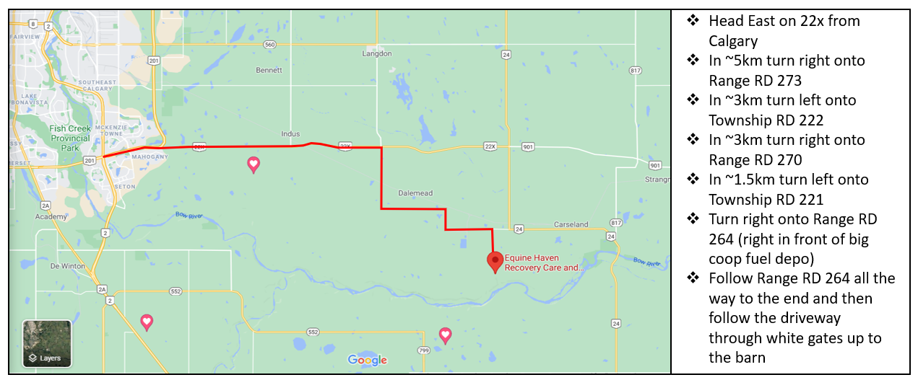
Please contact Heidi at 403-973-9693 if you require help with directions.

